KitsCo Company Limited,  1689 Arusha.  sales@kits.co.tz  +255 746 543 459 |   PROFORMA INVOICE

Sent To:
Community Wildlife Management Areas Consortium (CWMAC)
P.O. Box ,
Dar es Salaam - Tanzania, Tanzania
Att: Andrew Mariki < andrew.mariki@cwmac.or.tz >
 |  | Invoice # | 2123
 |  | Invoice Date | 29/02/2024
Due Date 10/03/2024
QTY | DESCRIPTION | UNIT PRICE | AMOUNT
13 | 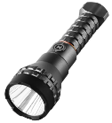  HEC Toolkit - MiniSet  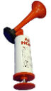  1 x LED Flashlight  1 x Horns  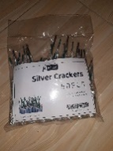  0.5 x Pack of ‘baruti’ i.e. 25pcs  1 x Roman candles  Will require 0.5 kg dry chili and 1 box condoms sold separately. | 500,000 | 6,500,000
 |  | TOTAL | Sh 6,500,000
Payments through the following bank account:
Bank name: CRDB
Account name: KITSCO COMPANY LTD
Account number: 015C754591000

