KitsCo Company Limited,  1689 Arusha.  sales@kits.co.tz  +255 746 543 459 | 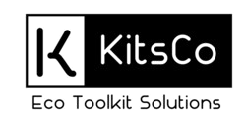  PROFORMA INVOICE

Sent To:
The Honeyguide Foundation
P.O. Box 8271,
Arusha, Tanzania
Att: finance@honeyguide.org
 |  | Invoice # | 2116
 |  | Invoice Date | 20/12/2023
Due Date 30/12/2023

QTY | DESCRIPTION | UNIT PRICE | AMOUNT
40 | LED Flashlights  NEBO Luxtreme 500-Lumen, NEB-FLT-1008  900 meters beam distance.  With USB type-C charging | 225,000 | 9,000,000
 |  | TOTAL | Sh 9,000,000
Payments through the following bank account:
Bank name: CRDB
Account name: KITSCO COMPANY LTD
Account number: 015C754591000

