KitsCo Company Limited,  1689 Arusha.  sales@kits.co.tz  +255 746 543 459 |   PROFORMA INVOICE

Sent To | Invoice # | 2110
STEP  P.O. Box 2494, Wiloles, IRINGA | Invoice Date | 28/07/2023
Due Date 07/08/2023
QTY | DESCRIPTION | UNIT PRICE | AMOUNT
2 | Fire crackers (50pcs packs) | 260,000.00 | 520,000.00
10 | Roman candles | 70,000.00 | 700,000.00
 |  | TOTAL | Sh 1,220,000.00
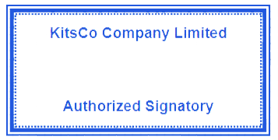
Payments through the following bank account:
Bank name: CRDB
Account name: KITSCO COMPANY LTD
Account number: 015C754591000

