KitsCo Company Limited,  1689 Arusha.  sales@kits.co.tz  +255 746 543 459 |   PROFORMA INVOICE

Sent To | Invoice # | 2106
STEP  P.O. Box 2494, Wiloles, IRINGA | Invoice Date | 26/06/2023
Due Date 06/07/2023
QTY | DESCRIPTION | UNIT PRICE | AMOUNT
3 | Fire crackers (50pcs packs) | 260,000.00 | 780,000.00
20 | Roman candles | 70,000.00 | 1,400,000.00
 |  | TOTAL | Sh 2,180,000.00
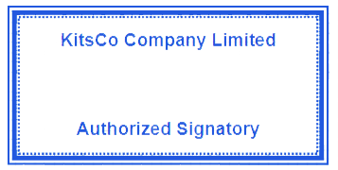
Payments through the following bank account:
Bank name: CRDB
Account name: KITSCO COMPANY LTD
Account number: 015C754591000

